AI FAQ Assistant AI - Al-powered FAQ and customer support automation.
Description:
The AI FAQ Assistant is a robust, secure, and intelligent REST API platform designed to streamline FAQ creation, user authentication, and Al-powered content management. Built with Node.js and Express.js, the application utilizes MongoDB as its primary data store along with Mongoose ODM for elegant data modeling and schema validation.

Security is central to the architecture, implementing JWT (JSON Web Tokens) for stateless user sessions and route guarding alongside bcrypt for strong password encryption. The backend handles intensive operations like automated FAQ generation, semantic search queries, and dynamic context parsing. It also features robust centralized error handling and response status sanitization to prevent unhandled database leakage and ensure operational durability.
Scenario-Based Case Study
Background
BHARAT.R is a customer support operations manager who handles massive backlogs of repetitive user inquiries but struggles to organize entries, classify topics, write precise summaries, and track client question trends efficiently.
Problem

- Difficulty generating and maintaining up-to-date documentation workflows.
- Limited visibility into semantic search match keywords and rapid query resolutions.
- Limited visibility into semantic search match keywords and rapid query resolutions.
- Time-consuming manual processes for drafting complex support answers.
- Lack of unified database permission layers protecting private documentation from public adjustments.

Solution

The Al FAQ Assistant backend delivers a centralized, secure API wrapper that decouples application business logic from frontend delivery systems. It introduces internal verification matrices controlling specialized services for content creation, category keywords, database persistence, and automated text inference modules.

Usage

- Authenticated Creator Usage: Registers profiles, requests instant Al assistance, drafts official FAQ schemas, and updates or removes self- authored records.

- Public/Consumer Usage: Queries general list routes to consume published articles and issues localized semantic queries via parameters.

Outcome

By offloading workflow controls to a robust backend, operational delays are minimized. Data structural integrity is strictly maintained through automated schema validation, security tokens guarantee that only original authors modify documents, and high-performance indexing facilitates real-time data discoverability.

1. Software Requirements

- Operating System: Windows 11, macOS, or Linux (supports cross- platform operations).

- Node.js (v18 or above): Runtime ecosystem running server logic and routing infrastructure.

- npm (v9 or above): Node package manager to control operational dependencies.

- Express.js (v4/v5 Ecosystem): Lightweight routing web framework to construct backend RESTful entry points.

- MongoDB / Mongoose ODM: Document NoSQL engine storing application users and curated data entities.

- Postman / ThunderClient: API verification toolkit to assert schema

- validation responses across administrative route shields. Code Editor: Visual Studio Code or similar IDE environment.

2. Hardware Requirements

- Processor: Intel Core i5 (8th Gen or above) / AMD Ryzen 5 or equivalent.

- RAM: 8 GB minimum (16 GB recommended for concurrent instances of MongoDB processing layers).

- Storage: 1 GB of available disk workspace

EPIC-1 PROJECT ARCHITECTUER:

EXTRNAL AI SERVICE:
GOOGLE GEMINI AI
GOOGLE GEMINI API

CLIENTS
WEB APP
MOBILE APP
API CLIENT
(POSTMAN,.)
API
EXPRESS.JS
CORS
JSON
ROUTE
MIDDLEWARE- LAYER
AUTH MIDDLEWARE
AUTHORIZATION
VALIDATION
CONTROLLER- LAYER
AUTH CONTROLLER
AI CONTROLLER
USER CONTROLLR
…

SERVICES LAYER:
AUTHSERVICE
FAQ SERVICE
USERSERVICE
AI SERVRICE
Data layer:(MongoDB)
*USERS COLLECTION
*FAQ COLLECTION
*OTHERS..
RATE LIMITING
(OPTIONAL)

ERROR HANDLING
(CENTRALIZED)

LOGGING
(MORGAN)

JWT
(STATELESS AUTH)

PASSWORD HASHING
(BCRYPT)

SECURITY
(HELMET, CORS)

AI FAQ Assistant API - Technical Architecture
= REQUEST FLOW

= RESPONSE FLOW

= DATA /SERVICE INTERACTION

The Al FAQ Assistant application exposes structured endpoints handled by a layered server architecture model. Incoming requests undergo filter processing before interacting with data services.

Components Definition

- Interface: API tools like Postman query distinct route paths to extract JSON entities

- Express Server Gateway: Monitors network ports, maps explicit HTTP methods (GET, POST, PUT, DELETE), parses incoming JSON payloads, and handles CORS headers.

- Authentication Middleware: Extracts tokens from headers, validates user context signatures, and evaluates authorization thresholds for guarded resource paths.

- Granular Services (Logic Modules): Enforces isolated domain rules for user.

- session life cycles and operational query modifications.

- Database Interface Layer: Mongoose translates operational application logic into performant native MongoDB queries.

- Al Flow (Service Integration): Connected to external Al models via Google Gemini SDK integrations, letting the controller layer offload complex question-answering tasks and automated topic generation workflows.

----------------------------------------------------------------------------------
Entity-Relationship (ER) Diagram Description

N 1

N 1
1
N
1
1
1
N
1 N
N 1
FAQ_LIKE
ID
FAQID
USERID
CREATEDAT

USER
NAME
EMAIL
PASSWORD
FAQ
ID
USERID
QUESTION
ANSWER
CATEGORYID
CATEGORY
ID (PK)
NAME
DESCRIPTION
CREATEDAT
UPDATEDAT

ANSWER_
FEEDBACK
ID
FAQID
USERID
COMMENT
ISHELPFUI

FAQ_TAG
ID
FAQID
TAG

TAG
ID
NAME
CREATEAT
CARDINALIT LEGEND
1 = ONE
2 = MANY

ENTITY DESCRIPTIONS
USER: Stores registered user(admin/creator/reader).
FAQ: Stores frequently asked question and their answers.
CATEGORY: Stores FAQ categories for better organization.
TAG: Stores tags/keywords for FAQs.
FAQ_TAG: Junction table for many-to-many relationship between FAQ and TAG.
FAQ_LIKE: Stores likes on FAQS by users.
ANSWER_FEEDBACK: Stores feedback on FAQ answers (helpful or not).

RELATIONSHIP SUMMARY
- USER 1-NFAQ
A user can create multiple FAQS.
- CATEGORY 1- NFAQ
A category can have multiple likes.
- FAQ 1 – N FAQ_LIKE
A FAQ can receive multiple FAQS.
- USER 1-N FAQ_LIKN
A user can like multiple FAQS.
- FAQ 1-N ANSWER _FEEDBACK
A FAQ can have multiple feedback.
- User 1- N ANSWER FEEDBACK
A user can provide feedback on multiple FAQs.
- FAQ 1- N FAQ_TAG
A FAQ can have multiple tags.
- Tag 1- N FAQ_TAG
A tag can be used in multiple FAQs.

----------------------------------------------------------------------------------

The backend database consists of multiple MongoDB collections connected through logical references to maintain user authentication, FAQ management, Al- generated content, and category organization.
----------------------------------------------------------------------------------
1. User Entity:
_id (Primary Key - Objected)
name (String, Required)
email (String, Required, Unique)
password (String, Hashed, Required)
role (String, Default: "user")
created At
updated At
----------------------------------------------------------------------------------
2. FAQ Entity:
_id (Primary Key - Objected)
question (String, Required)
answer (String, Required)
category (String, Required)
created By (Foreign Key referencing User Collection)
created At
updated At
----------------------------------------------------------------------------------
3. Al Generation Entity (Logical):
(Generated dynamically using Google Gemini Al before persistence.)
topic (String)
generated Question (String)
generated Answer (String)
generated Category (String)
generated At
----------------------------------------------------------------------------------
4. Category Entity (Logical):
category Name (String)
description (String)
total FAQs (Number)
----------------------------------------------------------------------------------
Key Structural Mappings
User→ FAQ (One-to-Many): A registered user can create and manage multiple FAQ records.
Category → FAQ (One-to-Many):
Each category can contain multiple FAQ documents.
User→ Al Generated FAQ (One-to-Many): A user can generate multiple Al-assisted FAQs, which may later be saved into the FAQ collection.
FAQ → Search Results (Logical Relationship):
Search queries retrieve matching FAQ documents using keyword and semantic matching.

----------------------------------------------------------------------------------

Key Features:

- JWT Authentication & Authorization: Secure token-based authentication protects private API endpoints.

- Al FAQ Generation: Google Gemini Al automatically generates questions, answers, and topic suggestions.

- Semantic FAQ Search: Intelligent keyword-based search enables faster information retrieval.

- Complete CRUD Operations: Create, Read, Update, and Delete FAQ records.

- Category Management: Organizes FAQs into structured categories for easier navigation.

- Password Encryption: User passwords are securely hashed using bcrypt before storage.

- Schema Validation: Mongoose validation ensures data integrity before database persistence.

- RESTful API Architecture: Modular Express.js routes provide scalable backend services.

- MongoDB Integration: Efficient NoSQL document storage using Mongoose ODM.

----------------------------------------------------------------------------

Roles and Responsibilities

Admin

- Manage all registered users.

- View, update, and delete any FAQ.

- Monitor Al-generated content.

- Manage FAQ categories.

- Access complete system functionality.
Content Creator

- Create new FAOs.

- Edit personal FAQ records.

- Delete owned FAQs.

- Generate FAQs using AI.

- Organize FAQs under categories.

Authenticated User

- View public FAQs.

- Search FAQs using keywords.

- Generate Al-assisted answers.

- Access personal profile information.

Public User

- View published FAQs.

- Search FAQs.
- Cannot create, edit, or delete FAQ records.
- No access to protected API endpoints.
-----------------------------------------------
USER FLOW
END
More Queries?
User Can
Like
Search Another FAQs
Go Back to list

User Views FAQS Answer
Display Relevant FAQs
Enter Search Query
System Searches FAQS

Search
View My FAQs
Edit My FAQS

Logout
Dashboard
READER
View
Like
Create FAQ
AUTHOR
Logout
Browse
Logout
Publish
Manage categories
EDITOR
Dashboard
Edit
Review Draft FAQs
View Analytics &Logs
Manage FAQS
Manage categories
Manage Users
Dashboard
Logout
ADMIN
ROLE VERIFICATION
GET JWT TOKEN
Authentication failed
Invalid Credentials
Try Again

START
REGISTER/LOGIN
USER

COMMON FLOW (APPLIES TO ALL AUTHENTICATED USERS)
API Request
With JWT Token
END

Return Response
Perform Action
Authorize Access

Token Validation

----------------------------------------------------------------------------------
MVC Architecture Pattern

The system architecture structures its source configuration layers around the Model-View-Controller design pattern to completely decouple components:
HAS FILES
/DB/ADMIN
/DB/USER
DB OPERATIONS
RESPONSE
REQUEST
ROUTES
DATABASE
MODAL
VIEW
CONTROLLR
USER
The system architecture structures its source configuration layers around the Model-View-Controller design pattern to completely decouple components:

Model Layer (Data Blueprint)

Defines structural blueprints via strongly enforced Mongoose schemas mapping explicit fields into raw collection items inside MongoDB. It sets field rules and defaults before validation persistence occurs.

Controller Layer (Execution Matrix)

The intermediary brain of the ecosystem. It captures request vectors from execution routes, checks structural request constraints, delegates processing workflows directly to models or services, and packages resultant output into standard JSON return arrays.

View Layer (Routing Network Interface)

In this pure headless backend service context, standard user-interface template views do not exist. Instead, the interface layer lives as an API Routing Layer. It links network requests on specified paths directly to their associated controller handler logic maps.
Epic 2: Project Setup and Configuration

Creating Project Folder

1.Create a new folder with your <project name>.

2. Inside that folder, create a new subfolder named src.

3.Now open that folder in VS Code.
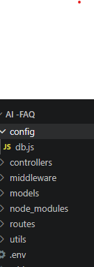
Server Setup (npm init)
Open your root folder terminal in VS Code and run:
Bash
Step 1:
npm init -y
step 2:
npm install express mongoose dotenv cors jsonwebtoken bcrypt
@google/genai
File and Folder Structure Matrix Plaintext
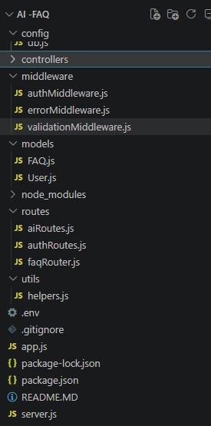
Epic 3: Backend Development
Core System Script Implementations

1. Gateway Server Node (src/server.js)
This main entrance mechanism aggregates environment variables, triggers database listeners, and binds network listeners to active environment ports:
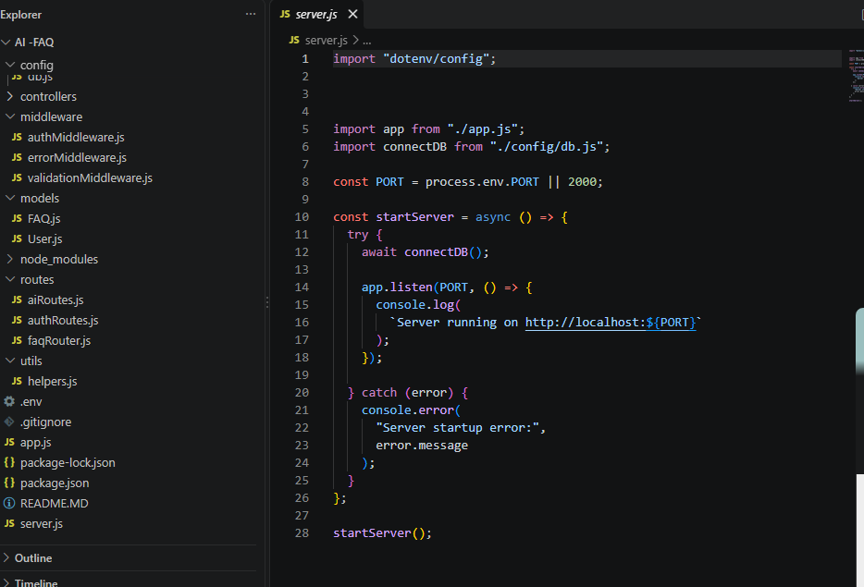
2. Gateway Express Setup (src/app.js)
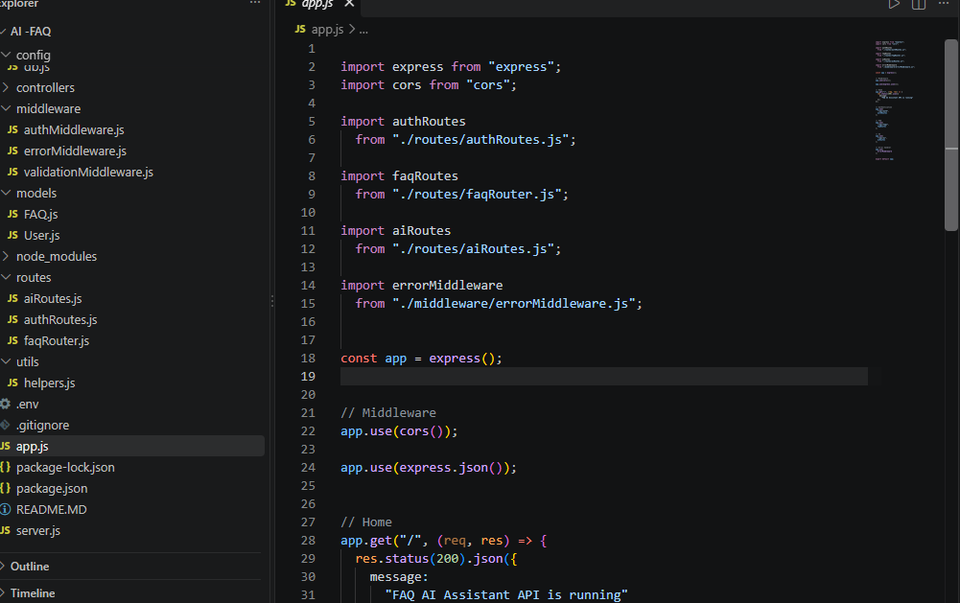

3. Security Access Middleware (src/middleware/authMiddleware.js)
Intercepts incoming target queries, extracts transmission header authorization records, and validates token identity context claims:

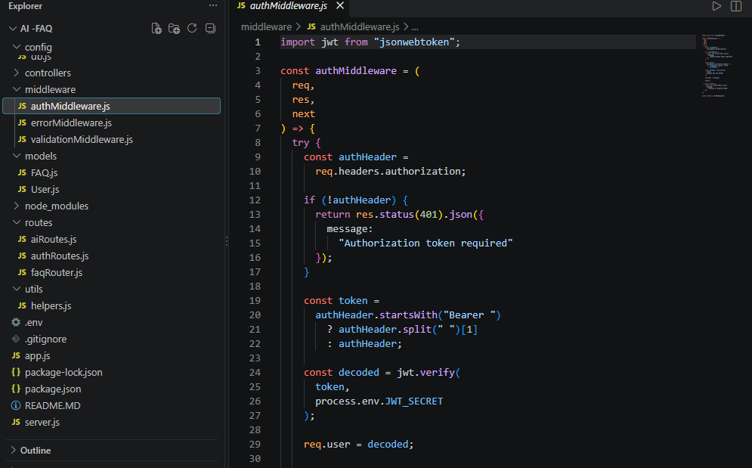

4. Centralized Error Handler Middleware (src/middleware/errorMiddleware.js).

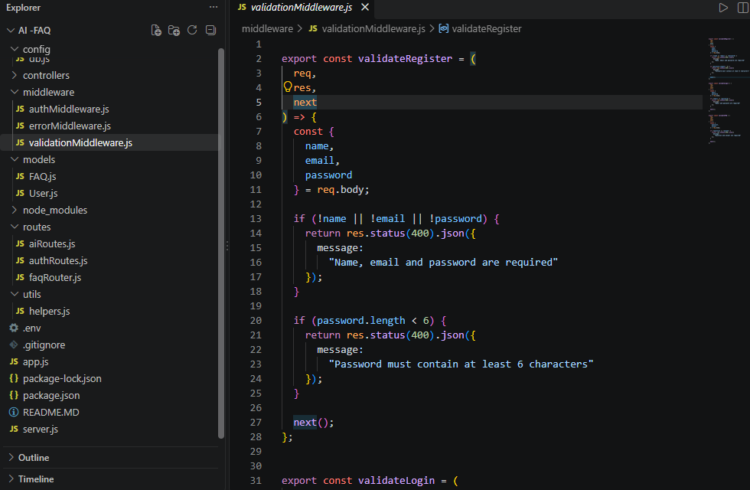

Epic 4: Database Configuration

Mongoose Schema Definitions

1. Identity Resource Document Schema (src/models/User.js)

Enforces profile field criteria validations and hooks password has to user document persistence:

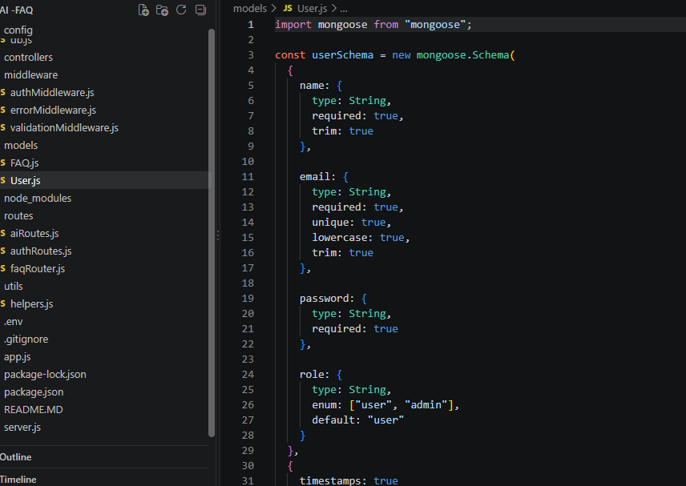

2. FAQ Resource Document Schema (src/models/FAQ.js)

Models core properties and maps a distinct relational reference link back to the source creator document:

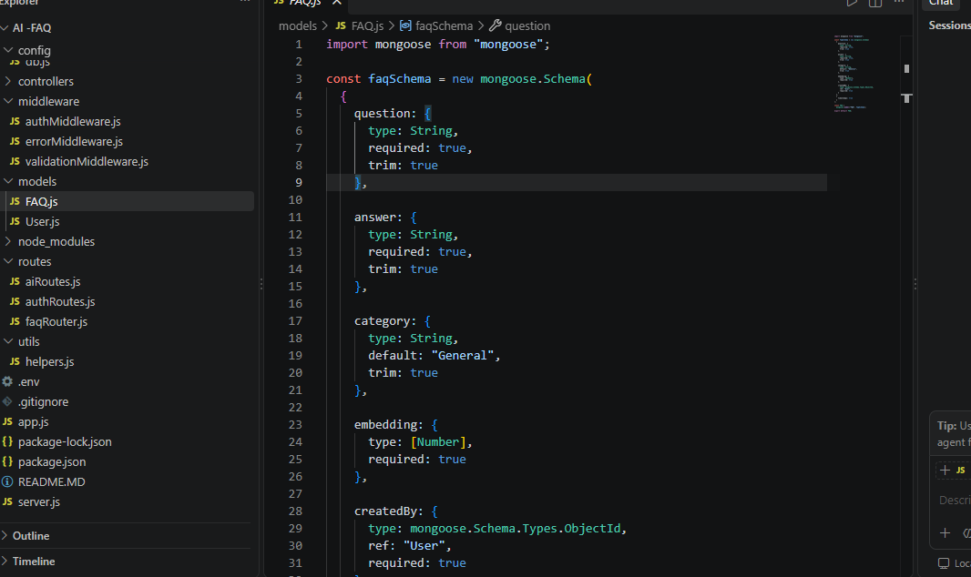

API Router Interface Endpoints

- Public Authentication Operations (src/routes/authRoutes.js)

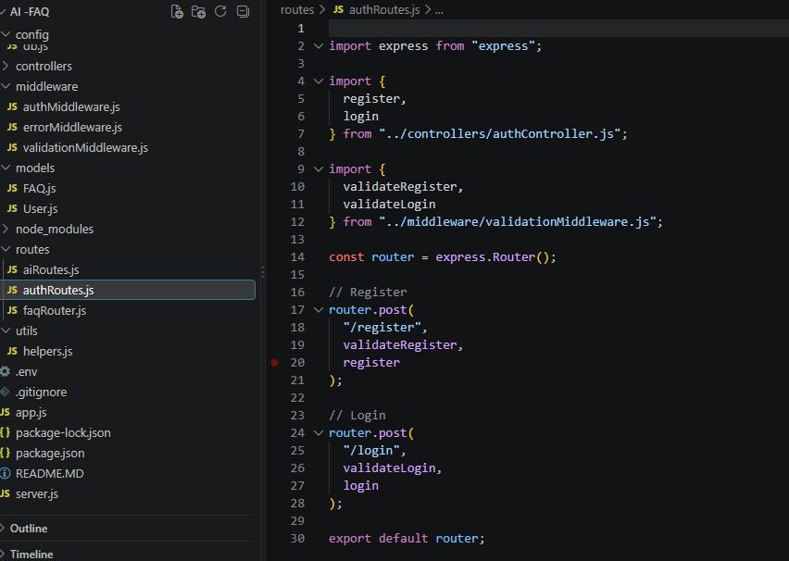

2.Protected FAQ Operations
(src/routes/faqRoutes.js) JavaScript

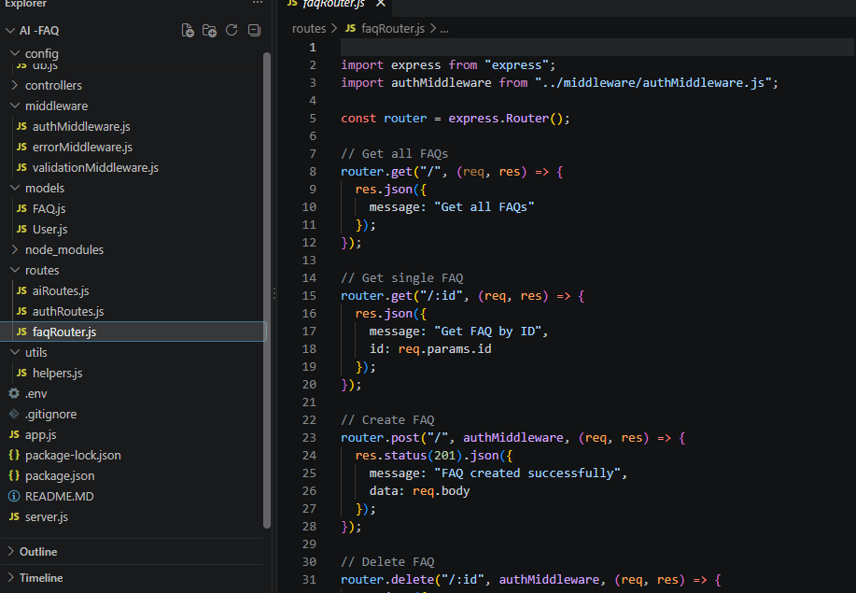

3.Al Automation Operations
(src/routes/aiRoutes.js)

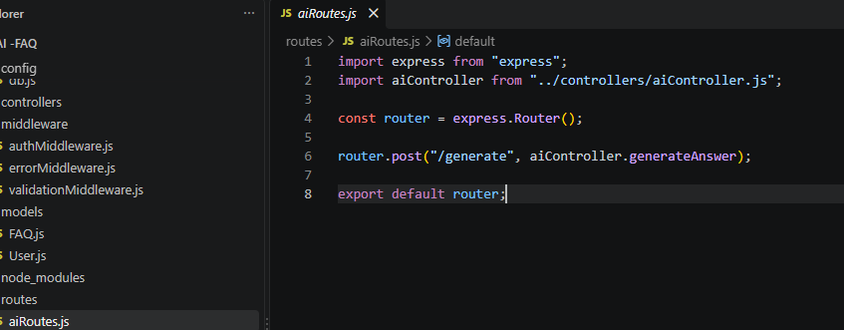

Epic 5: Project Executions

Running the API Application

- Install Postman or Thunder Client (VS Code extension).

- Start the backend development server environment parameters:

Bash
npm run dev
API Testing Specification Demo

To verify operational structural integrity via execution endpoints, map endpoints using the configurations below:

1. Identity Onboarding Path Registration

Route: POST/api/auth/register

Access: Public

Payload Request Body JSON:

JSON

}

"name": " Sharma",
"email": "sharma@gmail.com",
"password": "12345678"

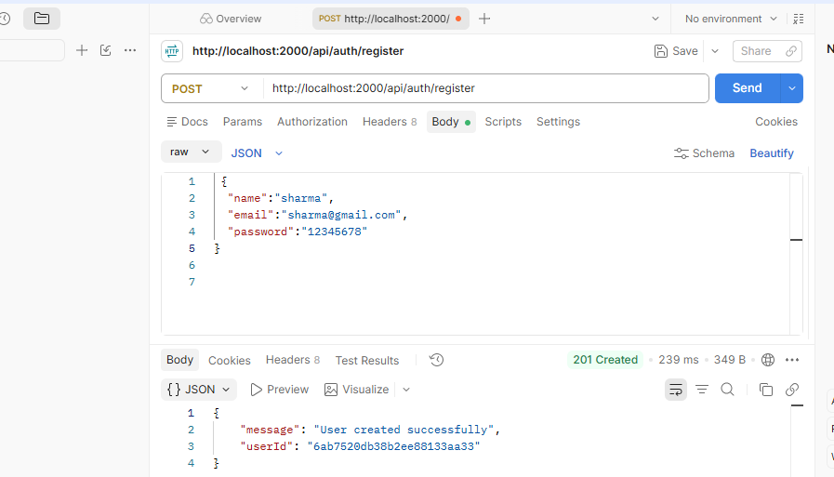

2. Profile Login Verification Quey

JSON

Route: POST /api/auth/login

Access: Public

Payload Request Body JSON:

"email": "sharma@gmail.com",
"password": "12345678"
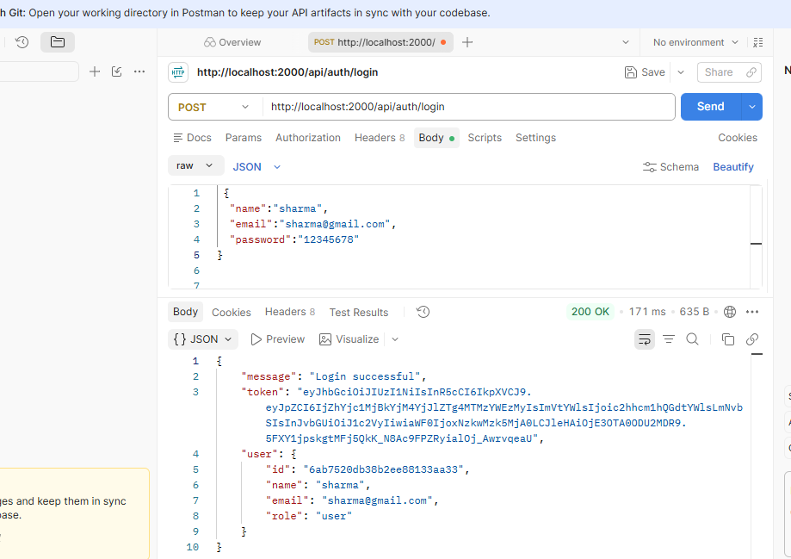

3. Resource Entity Creation (FAQ)

Route: POST/api/faqs

Access: Private (Bearer <JWT Token>)

Payload Request Body JSON:

tags arrays, and

JSON

"question": "How do I configure custom category tags?", "answer": "Navigate to settings panel, append keyword save schema.",
"category": "Configuration
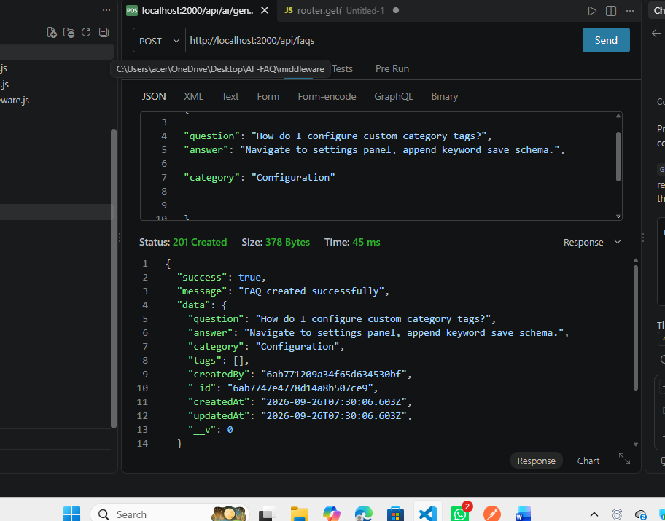

4. Keyword Resource Entity Fetching (Search)

Route: GET/api/faqs/search=configure

Access: Public
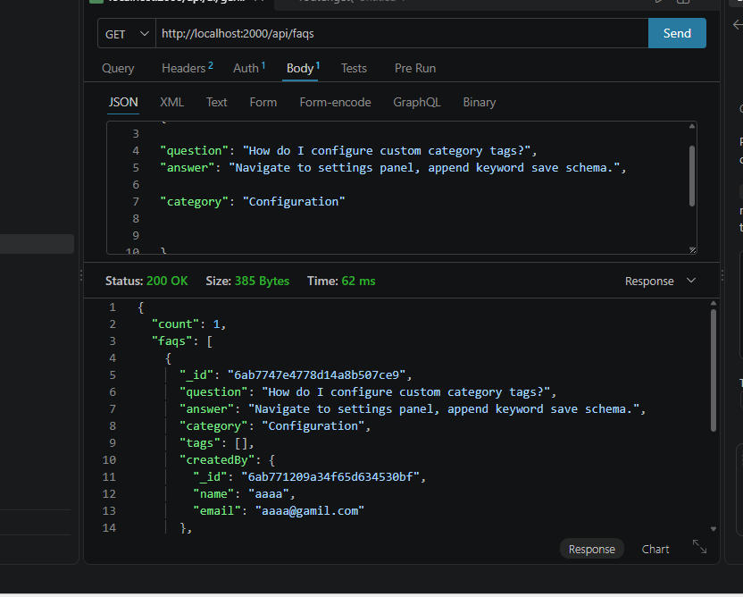

5. Al Intelligent Content Automation (Generate FAQ Pair)

Route: POST /api/ai/generate-faq
Access: Private (Bearer <JWT Token>)
Payload Request Body JSON
JSON
{
“topic”:”mongoose shchma index validation runtime workflow optimization”
}

API&DEMOlink:

CODE DRIVE: https://drive.google.com/drive/folders/1pX7-z9odjtqhNIX95vrMsCgY0d12kaef?usp=drive_link

